Target Audience
Healing Touch is a nursing based continuing education program for registered nurses, physicians, body therapists, counselors, psycho-therapists, other health professionals, and individuals desiring an in-depth understanding and practice of healing work using energy based concepts.

Healing Touch Program™ Description
A course of study toward a certificate of completion in Healing Touch (HT) which in-corporates a variety of basic to advanced healing modalities. The program is sequenced in 6 levels allowing participants to move from beginner to advanced practitioner, expert and instructor. Certification as a Healing Touch Practitioner and Instructor is available on application following completion of course work and additional requirements.

Level I Description
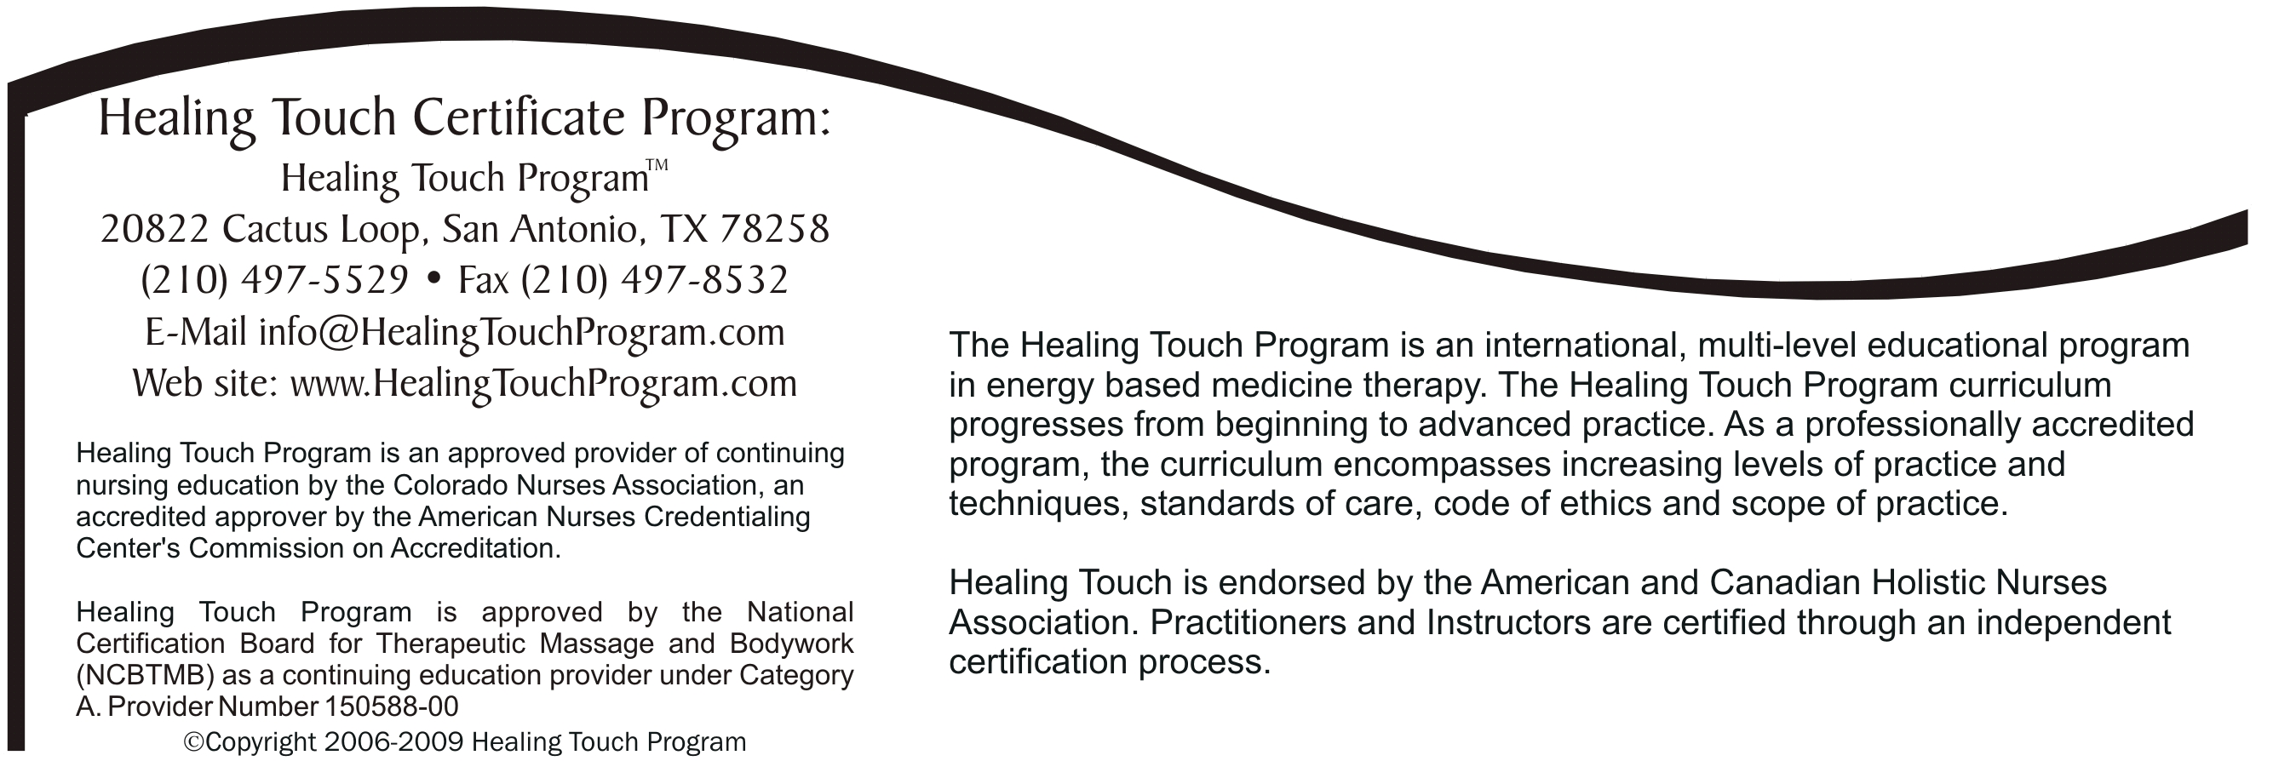
Level 1 begins with 16-18 continuing education contact hours of instruction, allowing persons with varying backgrounds to enter, acknowledge their previous learning and to further develop concepts and skills in energy-based therapy. A strong commitment to personal growth is required.

The participant will learn how to:
- Describe the human energy system relationship to physical, emotional, mental and spiritual health.
- Discuss energy principles basic to HT.
- Assess the energy field and energy centers.
- Identify a basic Healing Touch sequence.
- Demonstrate specific intervention techniques used in Healing Touch.
- Discuss applications of Healing Touch in personal and professional practice

Level I Course Content
- Energy system concepts related to health
- Basics of the energy system, energy field and energy centers
- Location and function of the chakras
- Assessment of the energy field and energy centers
- Meditation for centering and maintaining energetic flow
- Principles and practice of Healing Touch
- Selected intervention techniques: Basic Healing Touch Sequence, Magnetic Passes, Magnetic Clearing, Chakra Connection (1 on 1, 2 on 1, self), Headache Techniques (tension, migraine, sinus), Ultra Sound, Laser, Chakra Spread, Scudder (Optional), Mind Clearing (Optional)
- Principles of self-healing
- Personal development as a healer
- Legal and professional aspects of touch therapies

(16) Continuing Education Contact Hours

Workshop Information
Schedule: Sat, Sun, 8:30-6:00
Location: Holy Redeemer Home Care, 12265 Townsend Rd. Phila, Pa. 19154,

Coordinator: Jean M. White 215 757 2424, 267 374 0187, PAhealingtouch@gmail.com
Instructor: Jean M. White RN-BC, HN-BC, HTCI Jean has been a Certified Healing Touch Practitioner since 1998 and a Certified HolisticNurse since 1995.HTP Certified Instructor since 2008. She studied with Janet Mentgen, the creator of the program, through many classes that she coordinated in the Quakertown area 1995-2001. She has a successful private practice in Healing Touch and Holistic Nursing. She works psrttime as a Complementary Therapy Nurse at Holy Redeemer Hospice resides as facility mentor there integrating healing touch into end of life care.
Jean helps people through life transitions, beginnings and endings. Supporting the journey through balance and harmony, helping people grow and have fu

Learn more about Jean and Healing Touch at:
www.jeanwhitepahealingtouch
www.healingtouchpennsylvania.com

Registration Form
Healing Touch Level 1

12265 Townsend Rd,
Philadelphia, Pa. 19154

Name: ____________________________________
Address: __________________________________
City: ______________________________________
State: __________________ Zip: ______________
Home Phone: ______________________________
Work Phone: ______________________________
E-Mail: __________________________________

Please check one of the following:
Regular Tuition - $365 including manual.  HTPA or AHNA Member Tuition - $340 w/manual
Student - $255, w/manual
Repeat - $225 + manual if needed.
Register before January 1,2015. Save $10
$ Amount Enclosed (min. deposit $100)

Register Early!
Enrollment Limited!

Can you bring a massage table? 0 Yes 0 No
Make checks payable to: Jean M. White
Send to: 149 West Richardson Ave, Langhorne, Pa 19047

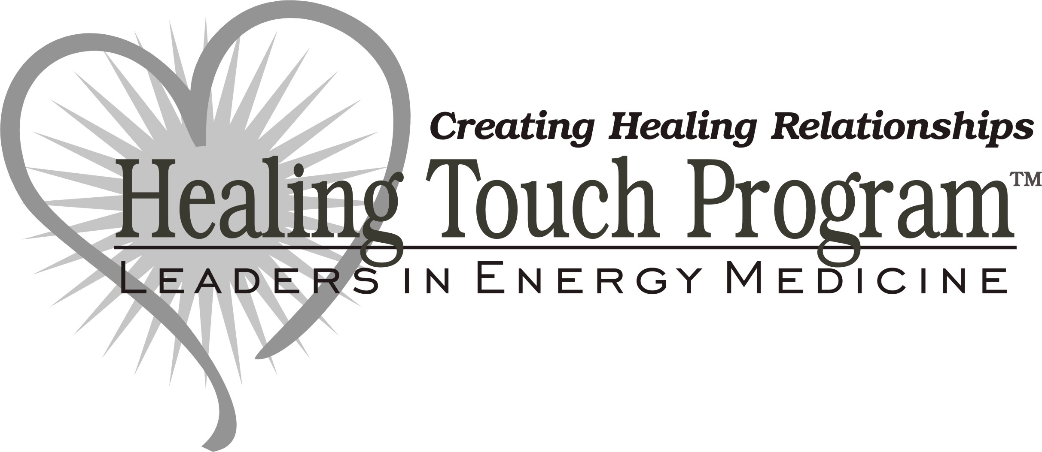

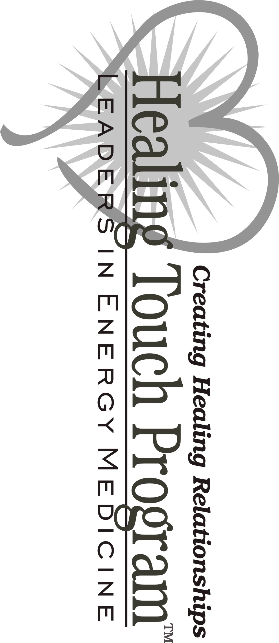

Level 1

Philadelphia, Pa 19154.

