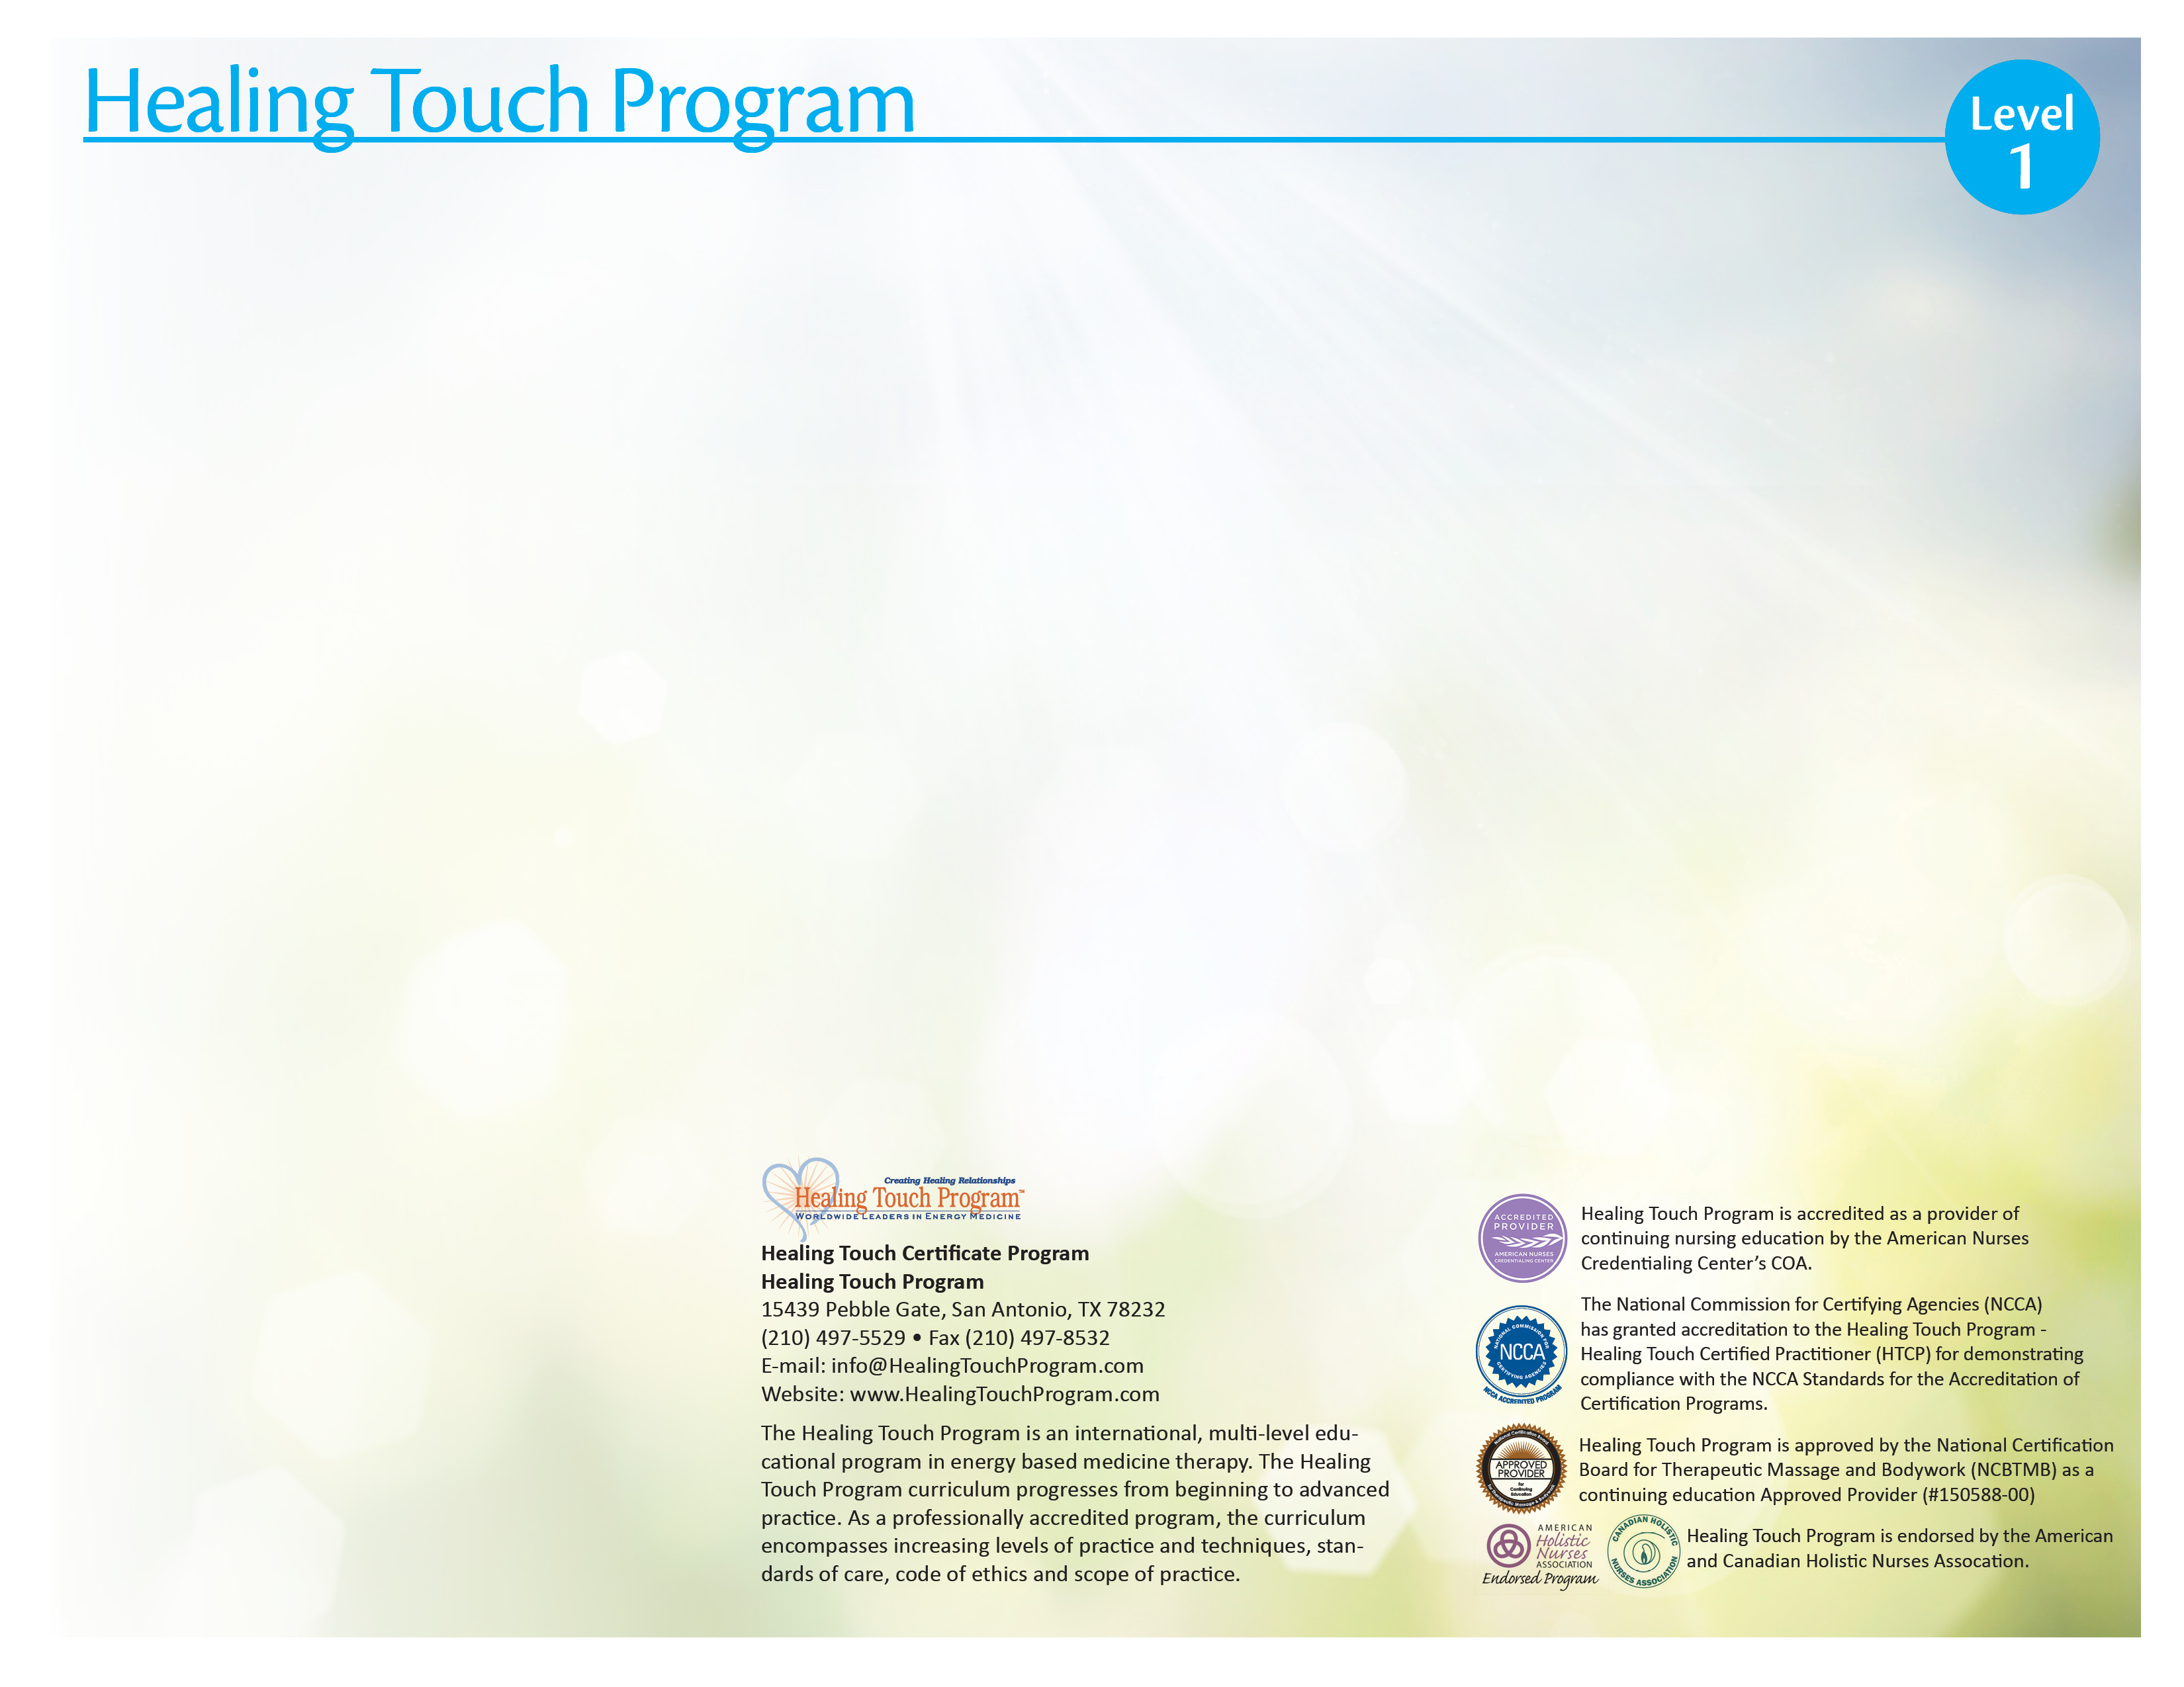
Target Audience
Healing Touch is a nursing based continuing education program for registered nurses, physicians, body therapists, counselors, psycho-therapists, other health professionals, and individuals desiring an in-depth understanding and practice of healing work using energy based concepts.

Healing Touch Program Description
A course of study toward a certificate of completion in Healing Touch (HT) which in-corporates a variety of basic to advanced healing modalities. The program is sequenced in 6 levels allowing participants to move from beginner to advanced practitioner, expert and instructor. Certification as a Healing Touch Practitioner and Instructor is available on application following completion of course work and additional requirements.

Level I Description
Level 1 begins with 16-18 continuing education contact hours of instruction, allowing persons with varying backgrounds to enter, acknowledge their previous learning and to further develop concepts and skills in energy-based therapy. A strong commitment to personal growth is required.

The participant will learn how to:
- Describe the human energy system relationship to physical, emotional, mental and spiritual health.
- Discuss energy principles basic to HT.
- Assess the energy field and energy centers.
- Identify a basic Healing Touch sequence.
- Demonstrate specific intervention techniques used in Healing Touch.
- Discuss applications of Healing Touch in personal and professional practice

Level I Course Content
- Energy system concepts related to health
- Basics of the energy system, energy field and energy centers
- Location and function of the chakras
- Assessment of the energy field and energy centers
- Meditation for centering and maintaining energetic flow
- Principles and practice of Healing Touch
- Selected intervention techniques: Basic Healing Touch Sequence, Magnetic Passes, Magnetic Clearing, Chakra Connection (1 on 1, 2 on 1, self), Headache Techniques (tension, migraine, sinus), Ultra Sound, Laser, Chakra Spread, Scudder (Optional), Mind Clearing (Optional)
- Principles of self-healing
- Personal development as a healer
- Legal and professional aspects of touch therapies

(16 or 18) Continuing Education Contact Hours

Workshop Information

Schedule: Sat, Sun, 8:30-6:00

Location: Holy Redeemer Home Care, 12265 Townsend Rd, Philadelphia, Pa 19154

Coordinator: Jean M. White 215 757 2424, 267 374 0187, PAhealingtouch@gmail.com

Instructor: Jean M. White RN-BC, HN-BC, HTCI Jean has been a Certified Healing Touch Practitioner since 1998 and a Certified Holistic Nurse since 1995.HTP Certified Instructor since 2008. She studied with Janet Mentgen, the creator of the program, through many classes that she coordinated in the Quakertown area 1995-2001. She has a successful private practice in Healing Touch and Holistic Nursing. She works part time as a Complementary Therapy Nurse at Holy Redeemer Hospice resides as facility mentor

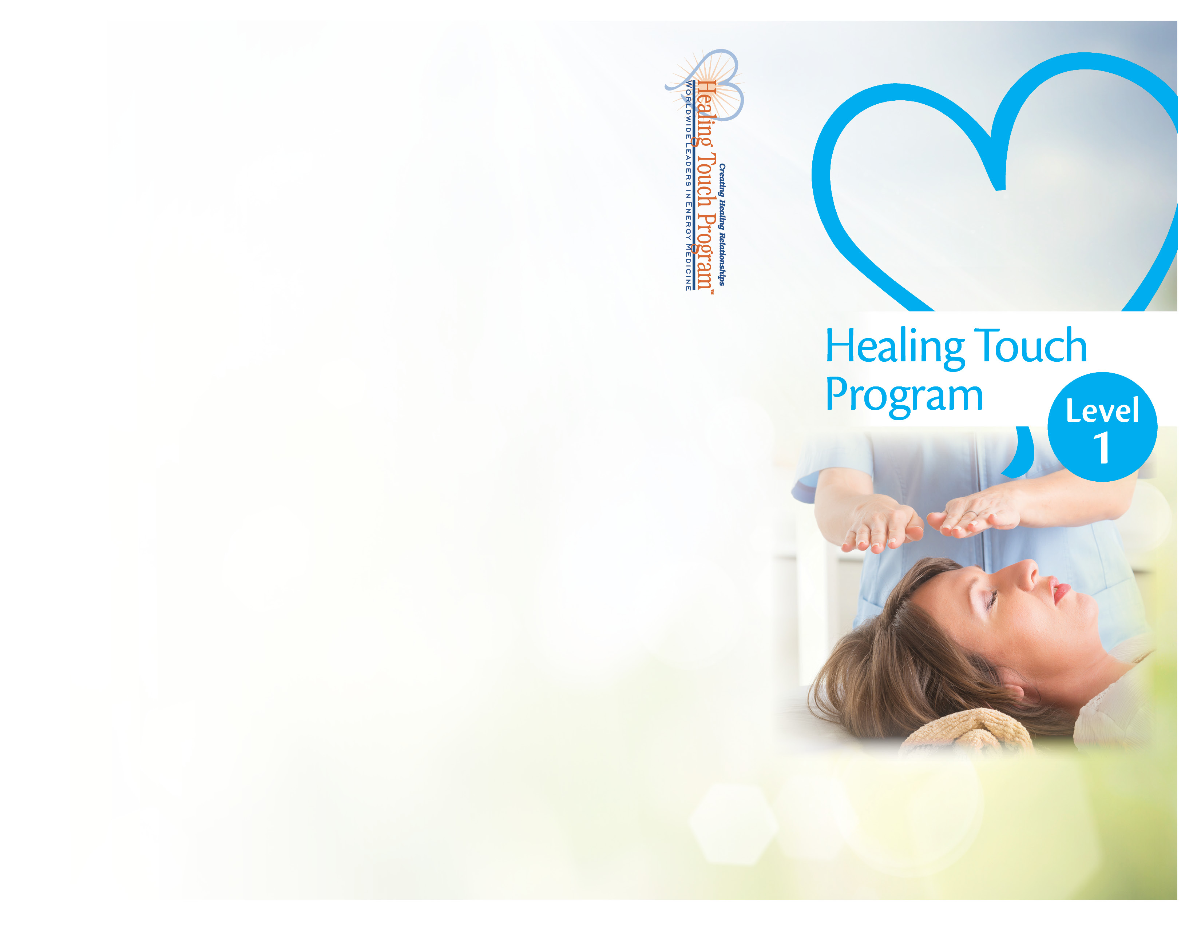
Holy Redeemer Home Care,
Registration Form
Healing Touch Level 1
Philadelphia, Pa
May 20-21, 2017
Name: ____________________________________
Address: __________________________________
City: ______________________________________
State: __________________ Zip: ______________
Home Phone: ______________________________
Work Phone: ______________________________
E-Mail: __________________________________

Please check one of the following:
- Regular Tuition - $365
- HTPA or AHNA Member Tuition - $340
- Student - $255
- Repeat - $255

$ Amount Enclosed (min. deposit $100)

Register Early!
Enrollment Limited!

Can you bring a massage table? __ Yes __ No

Make checks payable to: Jean M White
Send to: 149 West Richardson Ave, Langhorne, Pa 19047

Jean M White
149 West Richardson Ave
Langhorne, Pa. 19047

Philadelphia, PA
May 20-21. 2017

