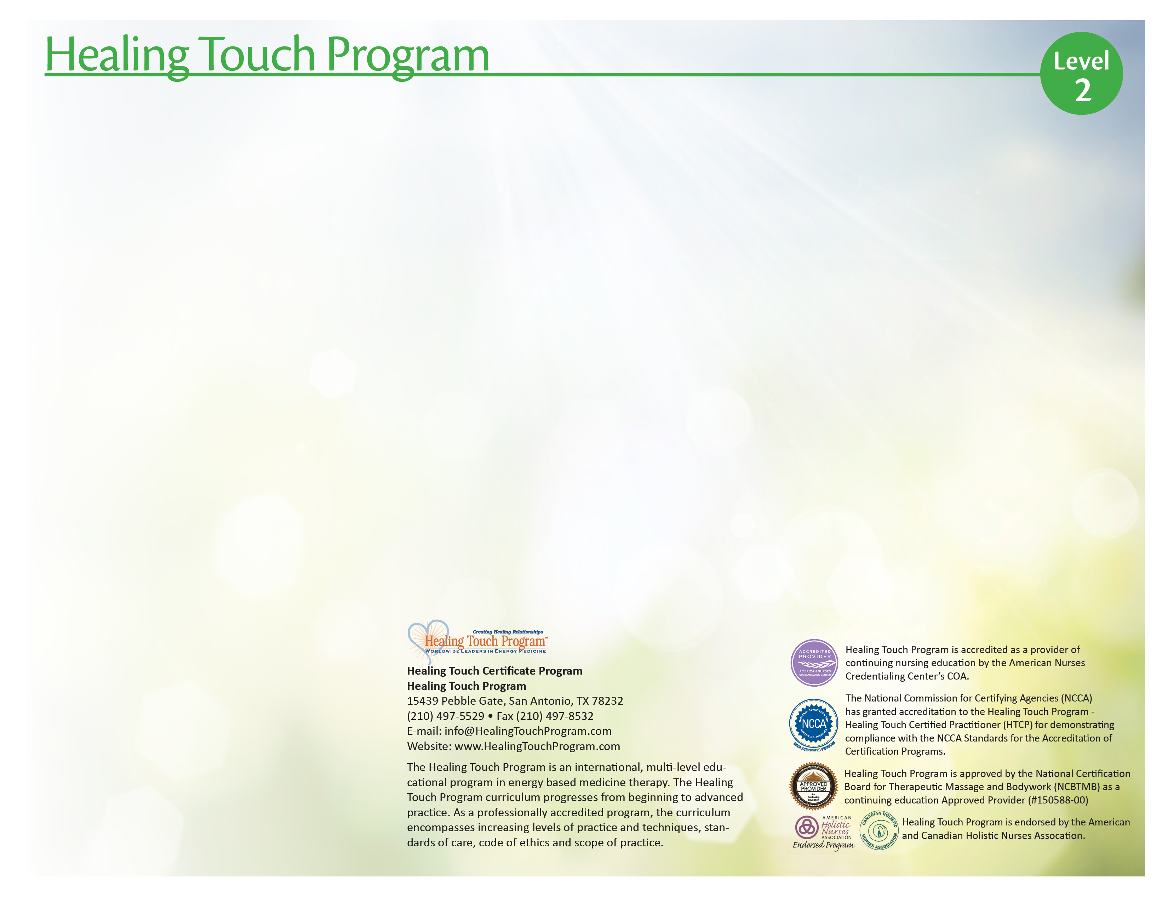
Target Audience
Healing Touch is a nursing based continuing education program for registered nurses, physicians, body therapists, counselors, psycho-therapists, other health professionals, and individuals desiring an in-depth understanding and practice of healing work using energy based concepts.

Healing Touch Program™ Description
A course of study toward a certificate of completion in Healing Touch (HT) which in-corporates a variety of basic to advanced healing modalities. The program is sequenced in 6 levels allowing participants to move from beginner to advanced practitioner, expert and instructor. Certification as a Healing Touch Practitioner and Instructor is available on application following completion of course work and additional requirements.

Level 2 Description
Level 2 is for students who have completed Level 1 and wish to increase breadth and depth in the study of Healing Touch. (16-18 continuing education contact hours.) The second level of study in Healing Touch includes an intake interview, back techniques and a one-hour healing sequence. Emphasis in the experiential learning is on developing healing sequences for specific client needs.

The participant will learn how to:
- Share the experience of practicing Level 1 techniques.
- Develop interviewing and additional assessment skills.
- Demonstrate a one-hour healing sequence for specific client problems.
- Document clinical work.
- Practice back and neck techniques.
- Discuss applications of Healing Touch in personal and professional practice
Level 2 Course Content
- Review techniques from HT Level 1
- Sharing experiences of practicing Level 1 techniques
- Discuss applying techniques in clinical settings
- Assessment process: interviewing skills, recording observations, documentation
- Healing techniques: One-hour Healing Sequence, Spiral Meditation, Mind Clearing, Wound Closing, Pain Ridge, Pain Drain, Sealing Leaks, Back Techniques
- Legal and professional aspects of touch therapies

(16 or 18) Continuing Education Contact Hours

Workshop Information

Schedule: Sat, Sun, 8:30-6:00

Location: Main Line Health, 240 Radnor Chester Rd, Radnor, Pa. 19087.

Coordinator: Jean M. White 215 757 2424, 267 374 0187, PAhealingtouch@gmail.com

Instructor: Jean M. White RN-BC, HN-BC, HTCI Jean has been a Certified Healing Touch Practitioner since 1998 and a Certified Holistic Nurse since 1995.HTP Certified Instructor since 2008. She studied with Janet Mentgen, the creator of the program, through many classes that she coordinated in the Quakertown area 1995-2001. She has a successful private practice in Healing Touch and Holistic Nursing. She works part time as a Complementary Therapy Nurse at Holy Redeemer Hospice and resides as facility mentor there.

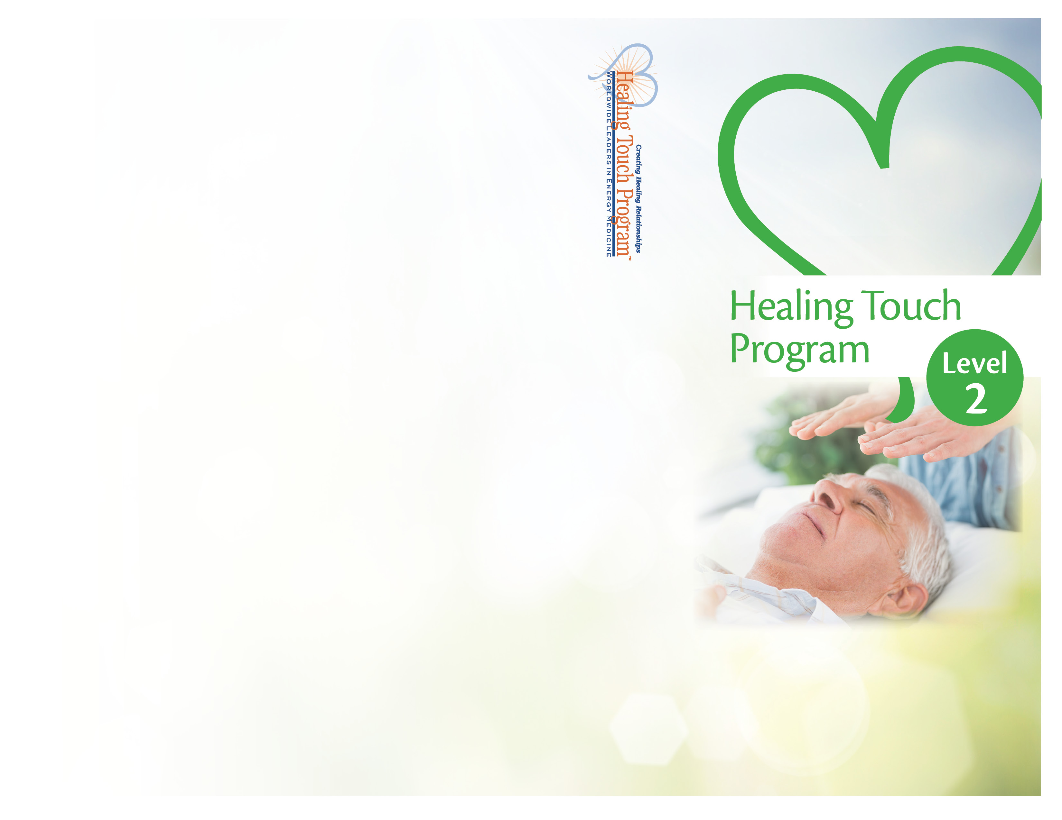
Radnor, Pa
Registration Form
Healing Touch Level 2
April 22-23, 2017

Name: ____________________________________
Address: __________________________________
City: ______________________________________
State: __________________ Zip: ______________
Home Phone: ______________________________
Work Phone: ______________________________
E-Mail: __________________________________

Please check one of the following:
- Regular Tuition - $365
- HTPA or AHNA Member Tuition - $340
- Student - $255
- Repeat - $255

$ Amount Enclosed (min. deposit $100)

Register Early!
Enrollment Limited!

Can you bring a massage table? __ Yes __ No

Make checks payable to: Jean M White, PAhealingtouch
Send to: 149 West Richardson Ave
Langhorne, Pa 19047

Jean M White
149 West Richardson Ave.
Langhorne, Pa 19047

Radnor, Pa
April 22-23, 2017

