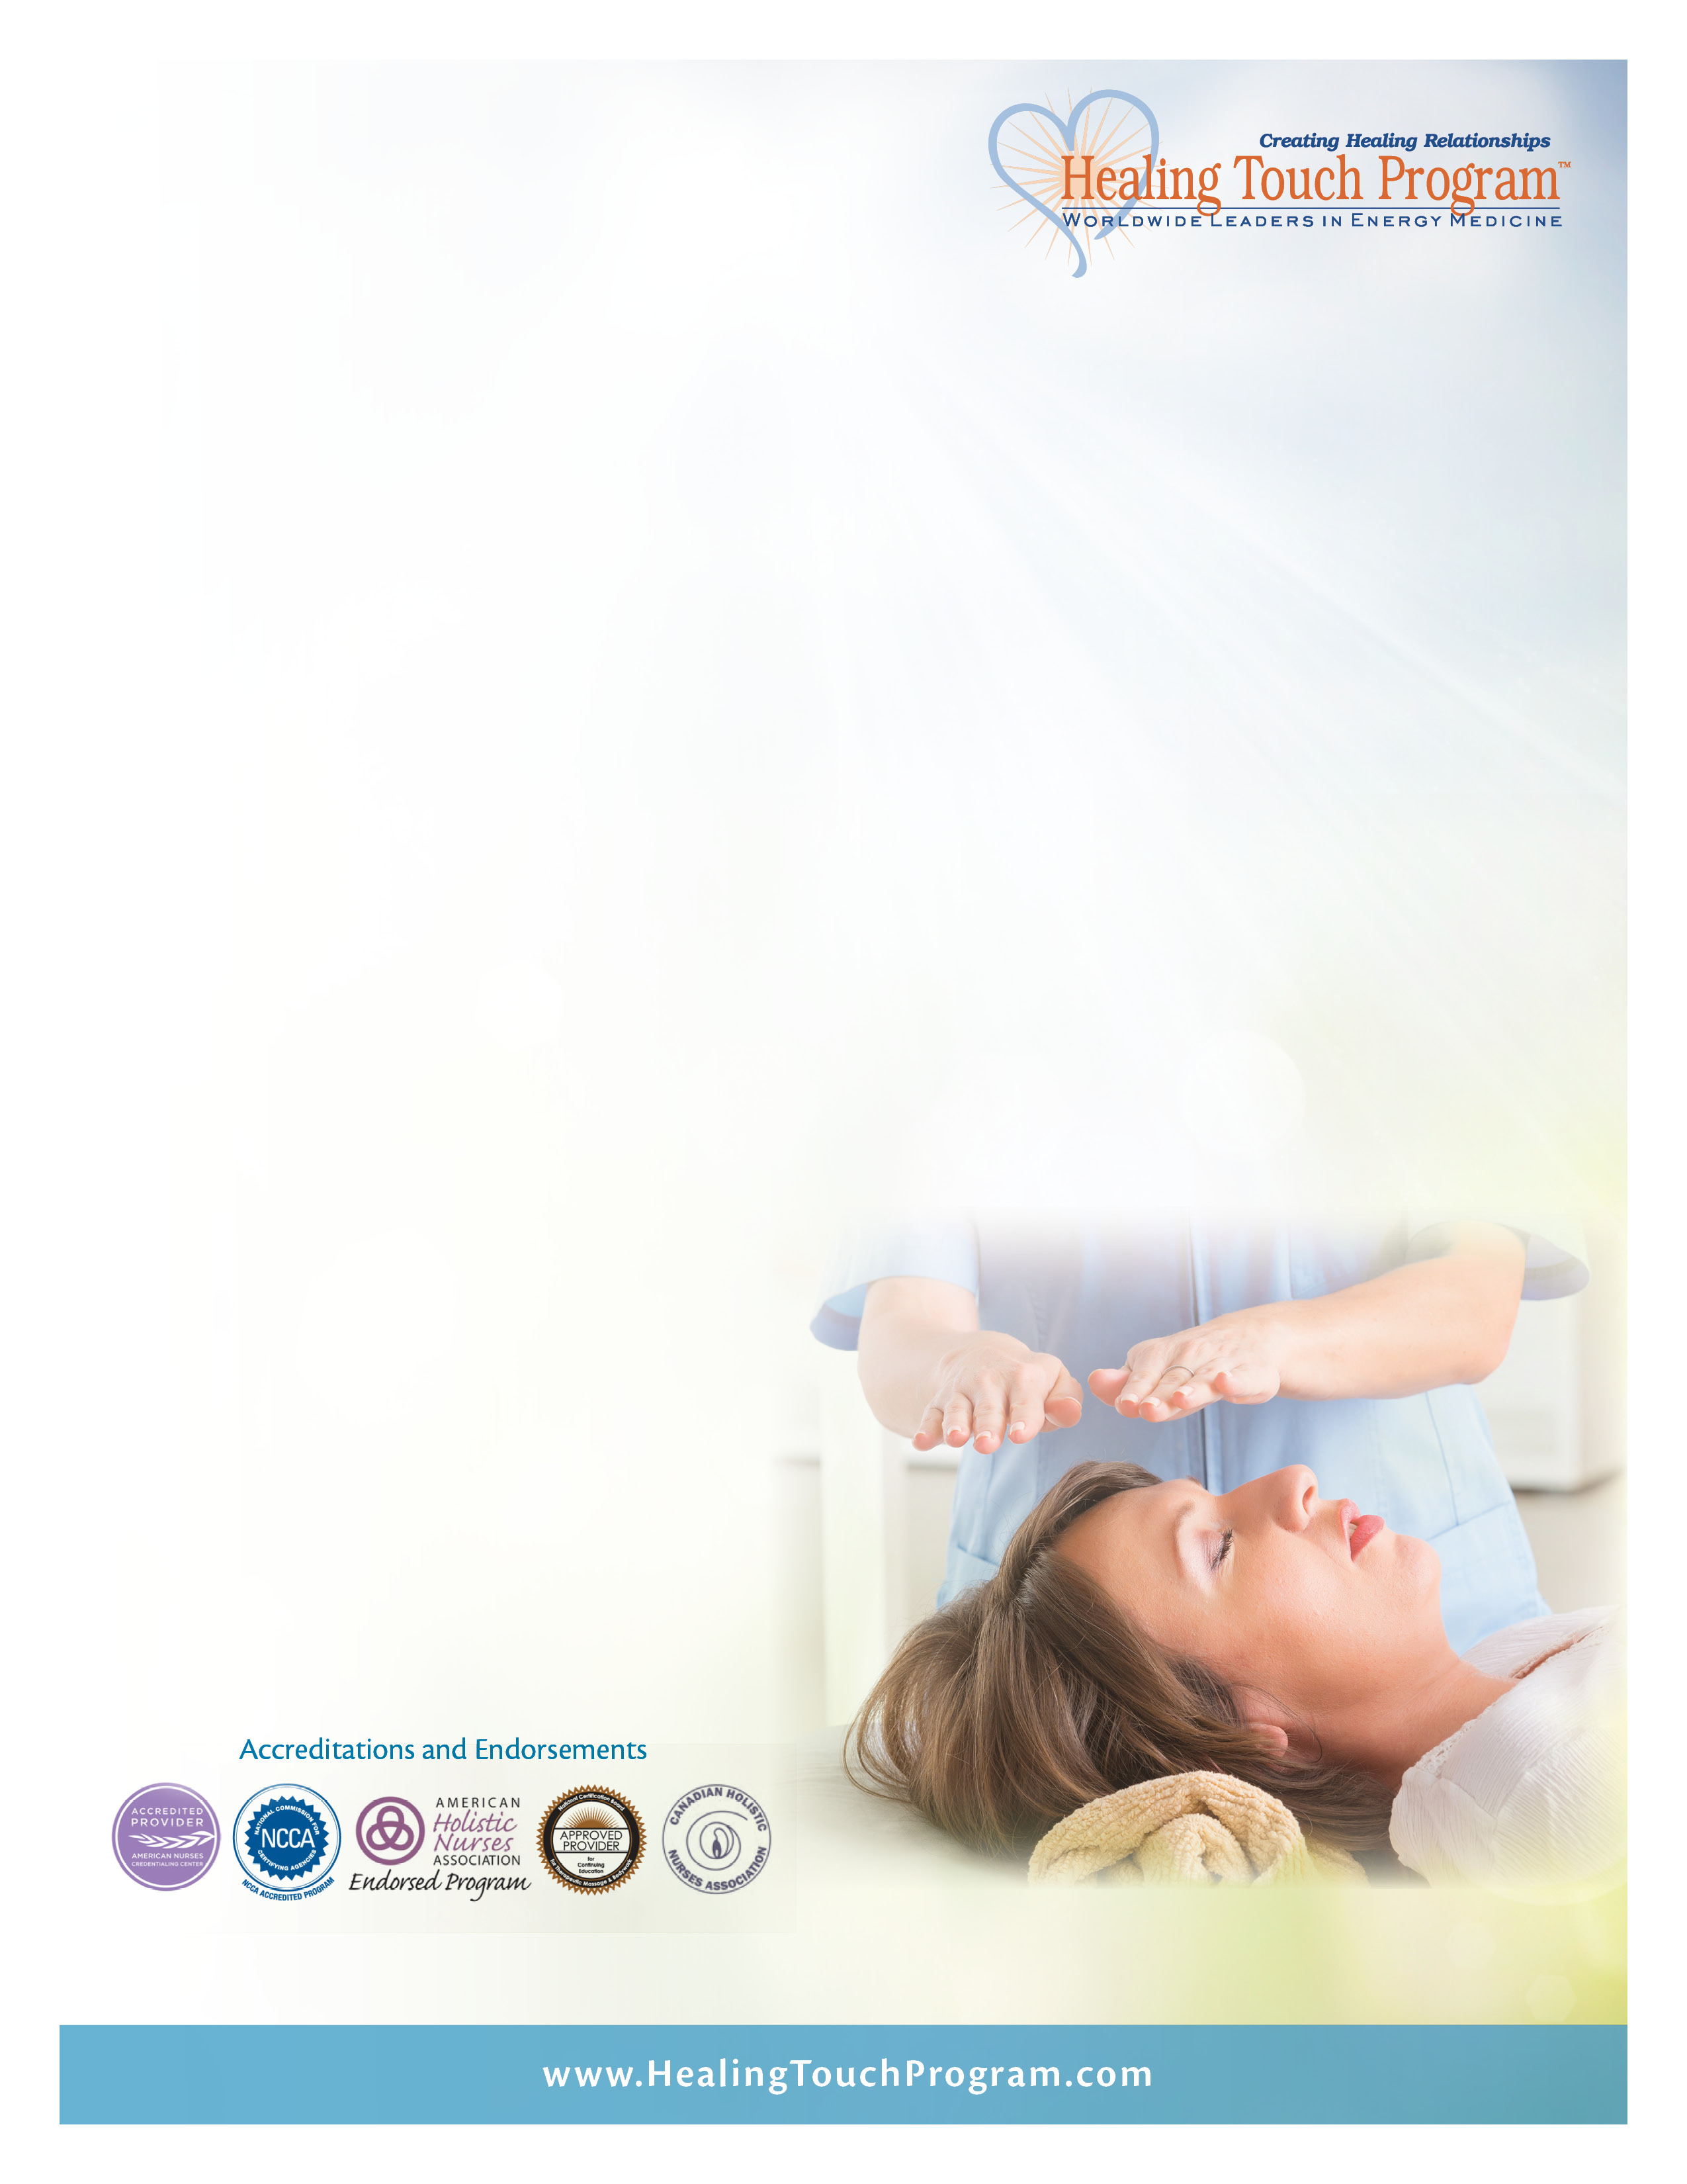

**Healing Touch Level 1**

Healing Touch helps you **embrace compassion in your work and world**. With Healing Touch you can gently, and significantly, impact the body-mind-spirit well being of people in your life and practice. After your first Healing Touch class you will possess a life-changing gift that you can offer over and over again to support health and facilitate the healing process for your patients and loved ones.

**WHAT IS HEALING TOUCH?**

Healing Touch is a **gentle, complementary energy-based approach to health and healing**. The goal is to restore harmony and balance to the human energy system through a heart-centered caring relationship and the **use of contact/non-contact touch**. This can greatly assist the body and mind in its natural ability to heal. Healing Touch is an **evidence-based practice** that offers continuing education for nurses and massage therapists.

**HEALING TOUCH:**

* Utilizes off body or light touch methods that clear congestion, relieves pain, facilitates   
  balance and promotes mind-body-spirit healing
* An international certification program
* A holistic practice that demonstrates Caring Science/Caring Theory (Dr. Jean Watson)
* Research based (www.HealingTouchResearch.com)
* Integrated in over 40 hospitals; Taught in over thirty countries
* Endorsed by American and Canadian Holistic Nurses’ Associations

Add this life-changing gift to your skills to help others as you deepen your personal and professional growth.

**This class is for you: all levels of health practitioners and interested lay people.**

**Location:** Radnor Main Line Health

**Date**: Feb 24-25, 2018

**Instructor: Your Name Here**

**Time:** 8:30 a.m. to 6:00 p.m.

**Tuition:** $497 (includes Level 1 Notebook)

**To Register:** Call Michele Tryson - 484 744-0205

*Course offers 16 Continuing Education contact hours for nurses and massage therapists.*

Healing Touch Program is accredited as a provider of continuing nursing education by the American Nurses Credentialing Center’s Commission on Accreditation. ©2017 Healing Touch Program Inc.